**Report**

|  |  |
| --- | --- |
| Team ID | NM2023TMID08697 |
| Project Name | Drowsiness detection and alerting System |
|  |  |

**Team Leader :** KARTHICK RAJAN V - 960620104011

**Team member :** AUGUSTIN M - 960620104302

**Team member :** SOOSAI ANTONY RUBAN A - 960620104022

**Team member :** MARIA SNEKA M – 960620104014

**1 .Introduction:**

**Project Overview:**

Drowsy driving is a significant cause of road accidents and fatalities worldwide. Fatigue and drowsiness can impair a driver's attention, reaction time, and decision-making abilities, putting both the driver and others at risk. To address this critical issue, advancements in technology have led to the development of Drowsiness Detection and Alerting Systems.

A Drowsiness Detection and Alerting System is a technological solution designed to monitor and analyze a driver's physiological and behavioral parameters in real-time to detect signs of drowsiness or fatigue. By employing various sensors and algorithms, these systems can effectively identify when a driver is becoming drowsy or losing concentration, thereby helping to prevent accidents caused by driver fatigue.

**Purpose:**

The primary goal of a drowsiness detection system is to provide timely warnings or alerts to the driver, allowing them to take necessary corrective actions and avoid potential accidents. The system typically utilizes non-invasive sensors, such as cameras, infrared sensors, or wearable devices, to capture vital signs and collect relevant data about the driver's physical state.

Once the data is collected, sophisticated algorithms analyze the information to detect patterns or indicators of drowsiness. These algorithms may consider factors such as eye movement, head posture, blink rate, steering wheel movements, and vehicle positioning. By continuously monitoring these parameters, the system can accurately determine the level of drowsiness and issue appropriate alerts.

The alerts generated by the system can take various forms, including audible alarms, vibrations, visual warnings on the dashboard, or even automated actions like seat vibrations or adjustments. These alerts serve as timely reminders for the driver to take a break, rest, or switch drivers if necessary.

Implementing a drowsiness detection and alerting system has the potential to significantly reduce accidents caused by drowsy driving. By providing real-time monitoring and proactive warnings, these systems promote driver safety and enhance overall road traffic safety. Additionally, they can also be integrated into fleet management systems, allowing organizations to monitor and address driver fatigue risks systematically.

**2 .Ideation and Proposed solution:**

**Problem Statement:**

• Driver Drowsiness Detection using Python , Jupiter Notebooks ,Tinker cad, Wokwi .

• The project as a system detects your eyes every time using a webcam and gives a Alert message (can be in form of alarm also) when a set threshold is reached .

• Drowsiness is detected with sensors and it alert with mobile phone

**Empathy Map Canvas:**

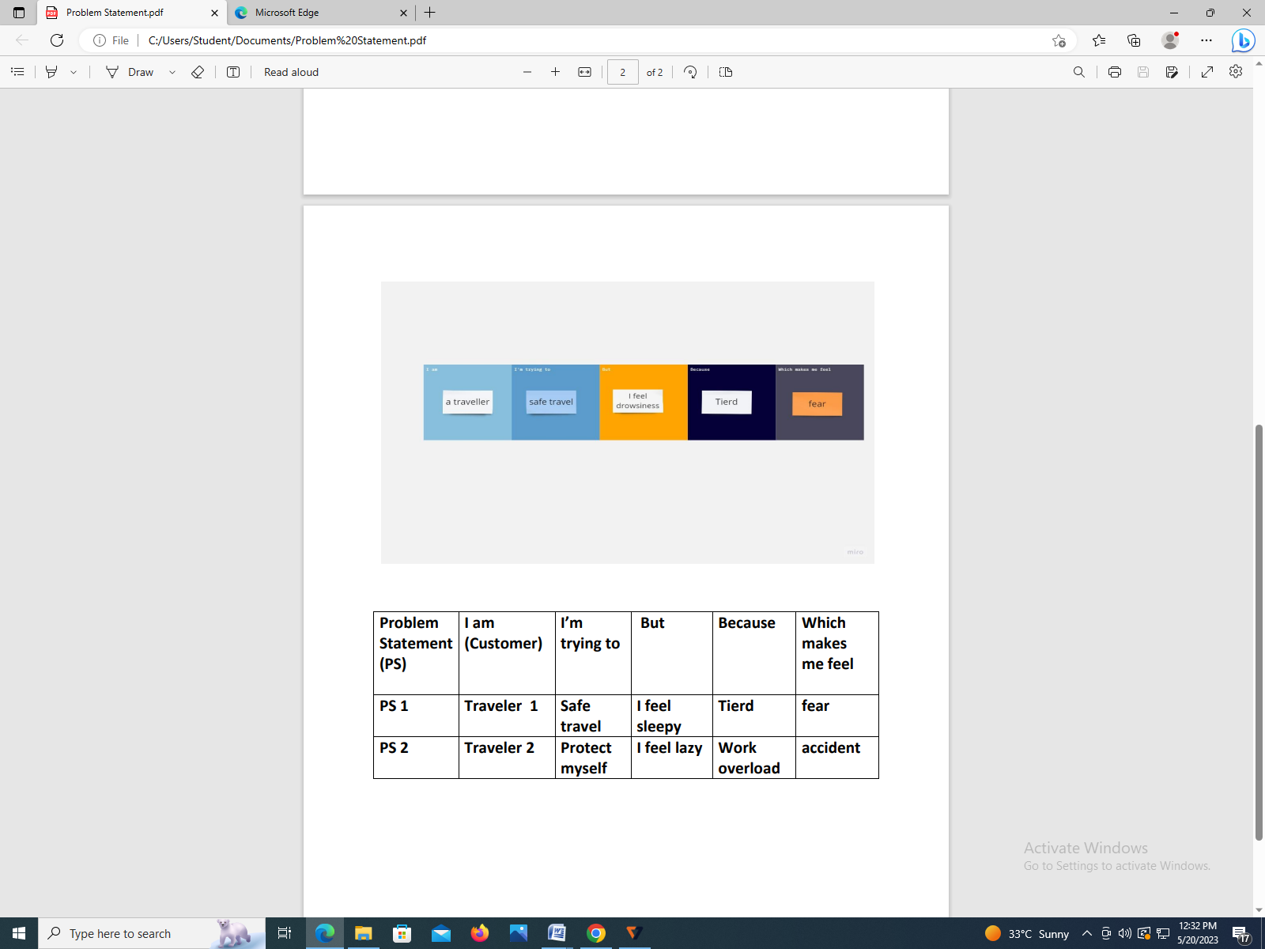

**System Architecture:**

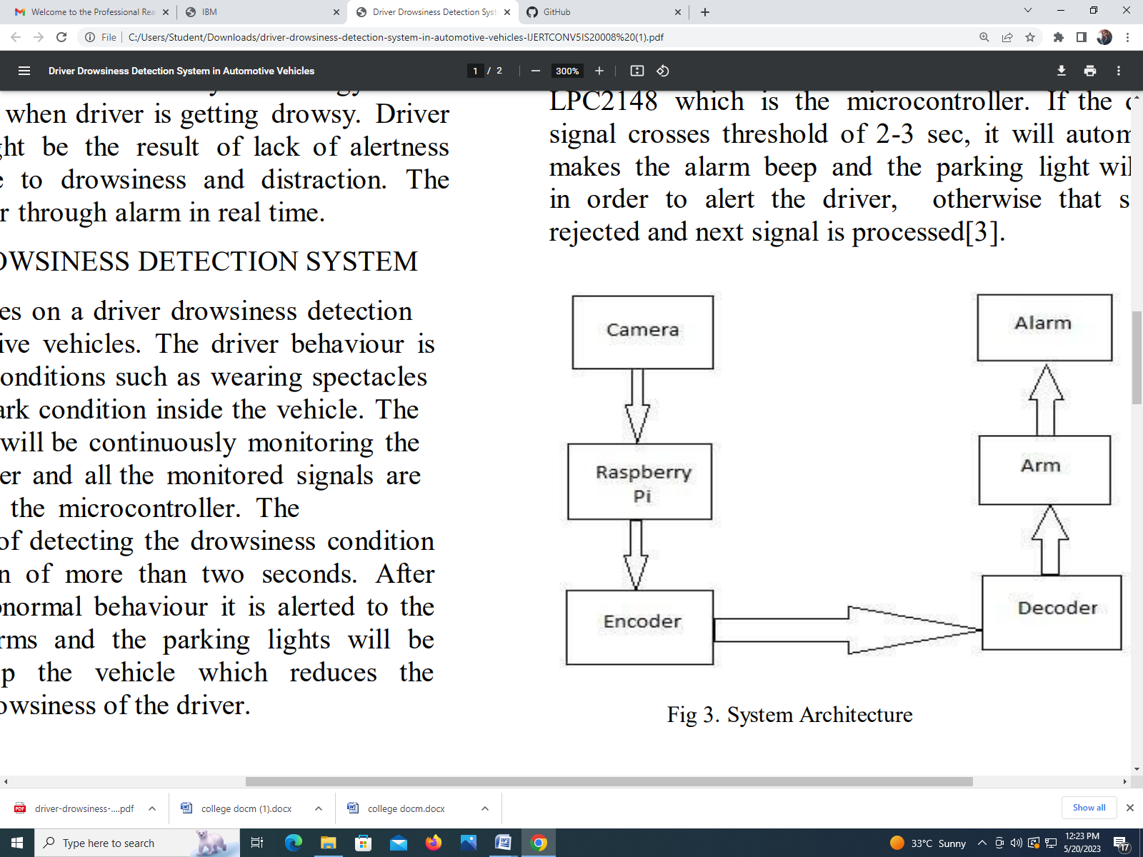

**3 .Requirement Analysis:**

**Functional requirement**:

To implement a drowsiness detection and alerting system, you can consider the following functional recurrence:

* **Data Acquisition:**

Capture physiological and behavioral data from the driver using non-invasive sensors such as cameras, infrared sensors, or wearable devices.

* **Preprocessing and Feature Extraction**:

Clean and preprocess the acquired data to remove noise or outliers.

* **Feature Selection and Dimensionality Reduction:**

Select the most informative features from the extracted set using techniques like statistical analysis or machine learning algorithms.

Perform dimensionality reduction if necessary to reduce computational complexity and improve model performance.

* **Training Data:**

Collect a labeled dataset containing instances of drowsy and alert states.

* **Model Development:**

Choose an appropriate machine learning or deep learning algorithm for drowsiness detection, such as logistic regression, support vector machines, random forests, or convolutional neural networks.

* **Model Evaluation:**

Assess the performance of the trained model using evaluation metrics such as accuracy, precision, recall, and F1-score.

* **Alerting Mechanism:**

Develop an alerting mechanism that generates timely warnings or alerts when the model predicts a drowsy state.Implement various alert formats such as audible alarms, vibrations, visual warnings, or automated actions.

* **Real-Time Monitoring and Integration**:

Integrate the trained model and alerting mechanism into a real-time monitoring system that continuously analyzes the driver's data.Ensure low-latency processing to provide immediate alerts and minimize response time.

* **Testing and Validation:**

Conduct extensive testing of the complete system under various scenarios and conditions.Validate the system's performance by comparing its predictions against ground truth observations or subjective ratings.

**Non-Functional requirements**

Here's a non-functional recurrence for a drowsiness detection and alerting system:

* **Reliability:**

Ensure the system consistently and accurately detects drowsiness and alerts the driver in real-time without false positives or false negatives.

Implement robust error handling and fault tolerance mechanisms to handle potential sensor failures or data inconsistencies.

* **Responsiveness:**

Design the system to detect drowsiness promptly and issue alerts without significant delay.Minimize latency in data acquisition, preprocessing, feature extraction, and model prediction to provide timely warnings to the driver.

* **User Interface:**

Create a user-friendly interface that allows drivers to easily understand the system's status, alerts, and instructions.Design clear and intuitive visual or auditory alerts that effectively convey the severity of drowsiness.

* **Scalability:**

Develop the system to handle a wide range of driving conditions, environments, and driver demographics.Ensure the system can scale to accommodate large-scale deployment, such as fleet management applications.

* **Security and Privacy**:

Implement robust security measures to protect the collected driver data from unauthorized access or misuse.Comply with privacy regulations by anonymizing or encrypting sensitive driver information.

* **Power Efficiency:**

Optimize the system's power consumption to minimize the impact on the vehicle's battery life.Implement energy-saving techniques such as sleep modes or intelligent sensor activation to conserve power when not actively monitoring for drowsiness.

* **Adaptability:**

Design the system to adapt to individual driver characteristics and preferences.Allow for customization or personalization of alert thresholds based on driver feedback or specific requirements.

* **Integration:**

Ensure seamless integration with existing vehicle systems or technologies, such as onboard diagnostics or telematics systems.

Enable interoperability with external devices or platforms for data sharing or analytics purposes.

* **Maintenance and Upgrades:**

Establish a system maintenance plan, including regular updates, bug fixes, and enhancements.

Provide mechanisms for remote monitoring, diagnostics, and over-the- air updates to improve system reliability and performance.

* **Compliance:**

Ensure compliance with relevant regulations and standards for road safety and automotive systems, such as ISO 26262 or local traffic laws.By considering these non-functional aspects, you can develop a drowsiness detection and alerting system that not only effectively detects drowsiness but also meets the requirements for reliability, responsiveness, user interface, scalability, security, power efficiency, adaptability, integration, maintenance, and compliance.

**4 .Project Design:**

**Solution architecture:**

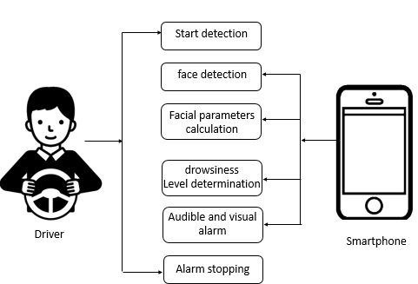

**Data Flow Diagram**

Data flow diagram for Drowsiness detection and alerting System was given below.

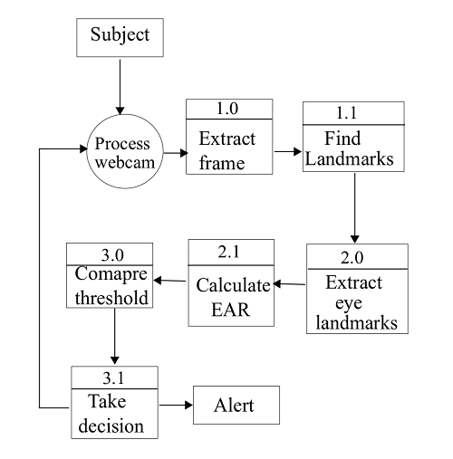

**5 .Coding:**

#include <Servo.h>

#include <LiquidCrystal.h>

Servo servo;

LiquidCrystal lcd(12, 11, 5, 4, 3, 2);

const int PIRpin=7;

const int buzzerPin=6;

const int ledPin=8;

int sensorValue = 0;

long duration, distance;

void setup()

{

Serial.begin(9600);

servo.attach(9);

servo.write(0);

pinMode(PIRpin, INPUT);

pinMode(buzzerPin, OUTPUT);

pinMode(ledPin, OUTPUT);

lcd.begin(16, 2);

lcd.setCursor(0, 0);

lcd.print("DRIVER DROWSINESS");

lcd.setCursor(1, 1);

lcd.print("DETECTOR BY SRI");

delay(2000);

}

void loop()

{

lcd.begin(16, 2);

lcd.setCursor(0, 0);

lcd.print("DRIVER DROWSINESS");

lcd.setCursor(1, 1);

lcd.print("DETECTOR BY SRI");

delay(500);

if(digitalRead(PIRpin)==1)

{

lcd.clear();

lcd.setCursor(1, 0);

lcd.print("Driver Drowsy !");

lcd.setCursor(0, 1);

digitalWrite(buzzerPin,HIGH);

digitalWrite(ledPin,HIGH);

delay(500);

digitalWrite(ledPin,LOW);

delay(500);

digitalWrite(ledPin,HIGH);

delay(500);

digitalWrite(ledPin,LOW);

delay(500);

digitalWrite(buzzerPin,LOW);

servo.write(90);

delay(5000);

servo.write(0);

}

}

**Circuit Diagram:**

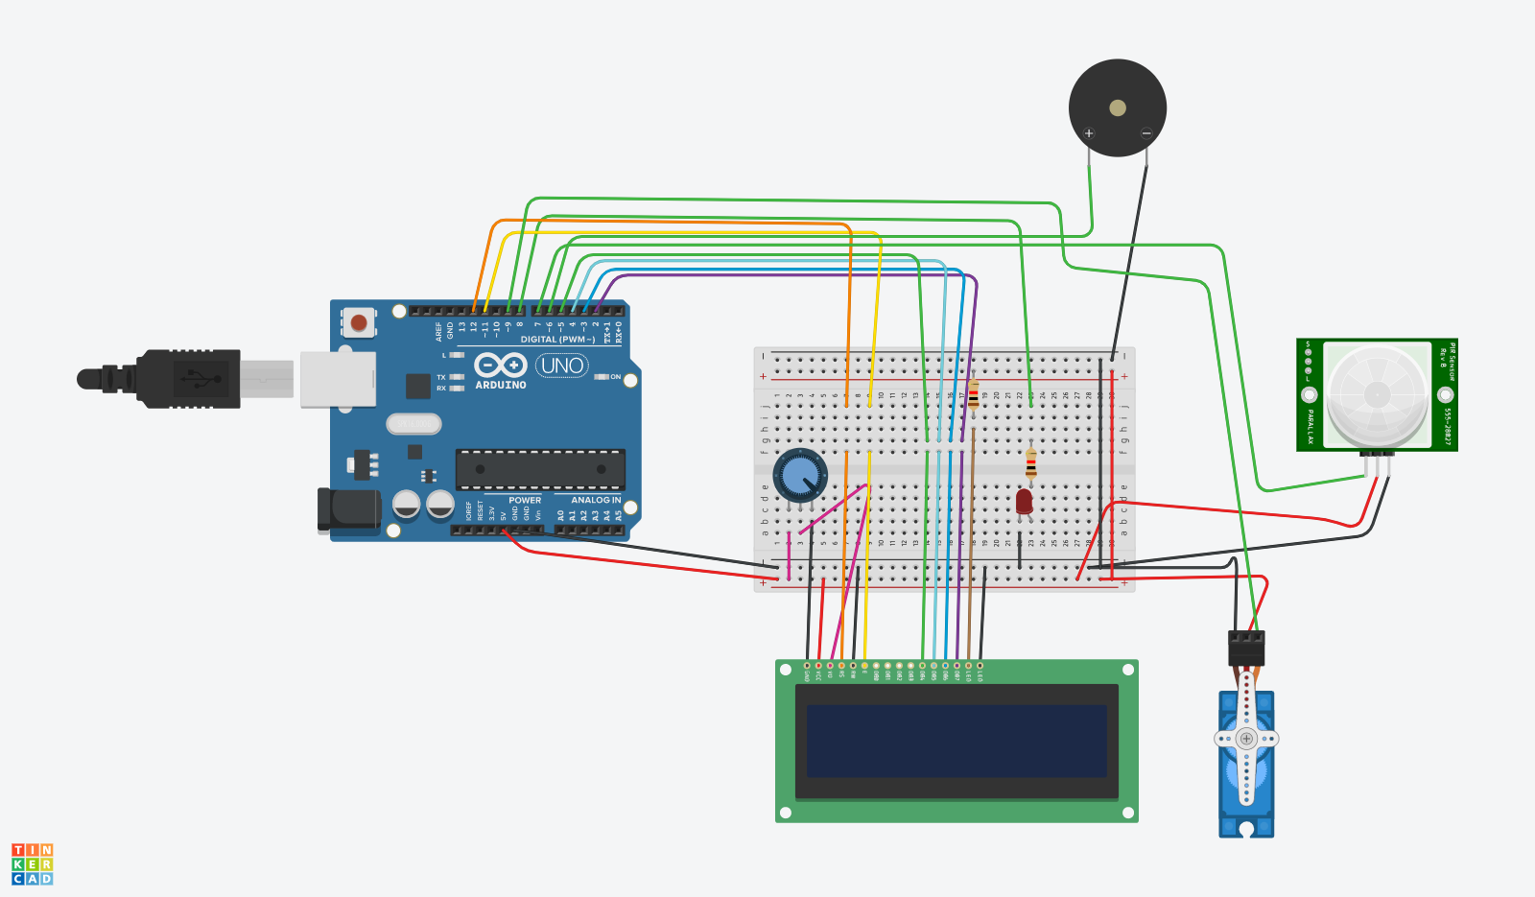

**6 .Result:**

* **Accident prevention**:

Drowsiness is a leading cause of accidents, especially in settings such as driving, operating heavy machinery, or working in critical professions. A drowsiness detection system can help identify early signs of fatigue, allowing individuals to take necessary breaks or corrective actions to prevent accidents.

* **Increased safety:**

By alerting individuals when they are becoming drowsy, the system promotes safety in various contexts, such as transportation, manufacturing, healthcare, or any occupation where fatigue-related errors can have severe consequences. It helps ensure that individuals remain alert and responsive during critical tasks.

* **Enhanced productivity**:

Fatigue and drowsiness can significantly impact productivity and performance. A detection and alerting system can help individuals recognize their fatigue levels and take appropriate measures, such as resting or engaging in rejuvenating activities, to maintain their productivity and efficiency.

* **Personal health and well-being:**

Chronic sleep deprivation and excessive drowsiness can have adverse effects on an individual's overall health and well-being. By providing real-time alerts and promoting better sleep habits, the system encourages individuals to prioritize rest, leading to improved physical and mental health.

* **Customizability:**

Drowsiness detection and alerting systems can be personalized based on individual needs and preferences. They can consider various factors, such as individual sleep patterns, behavioral characteristics, and environmental conditions, to deliver tailored alerts and recommendations for managing drowsiness effectively.

* **Early warning signs:**

Drowsiness detection systems can often identify subtle signs of fatigue before an individual even realizes they are becoming drowsy. By providing early warnings, individuals can take preventive measures to avoid drowsiness-related accidents or errors.

* **Real-time monitoring**:

These systems typically provide real-time monitoring, feedback can help users understand their patterns of fatigue, make informed decisions, and adjust their behavior accordingly.

* **Data-driven insights**:

By collecting and analyzing data on drowsiness patterns, these systems can provide valuable insights. This data can help individuals, researchers, and organizations understand the causes and consequences of drowsiness, leading to the development of better fatigue management strategies and interventions.

.

**Simulation link:** <https://www.tinkercad.com/things/dYhyWst7d4-driver-drowsines-detection-system-using-sensors/editel?tenant=circuits>

**Screenshots of Result:**

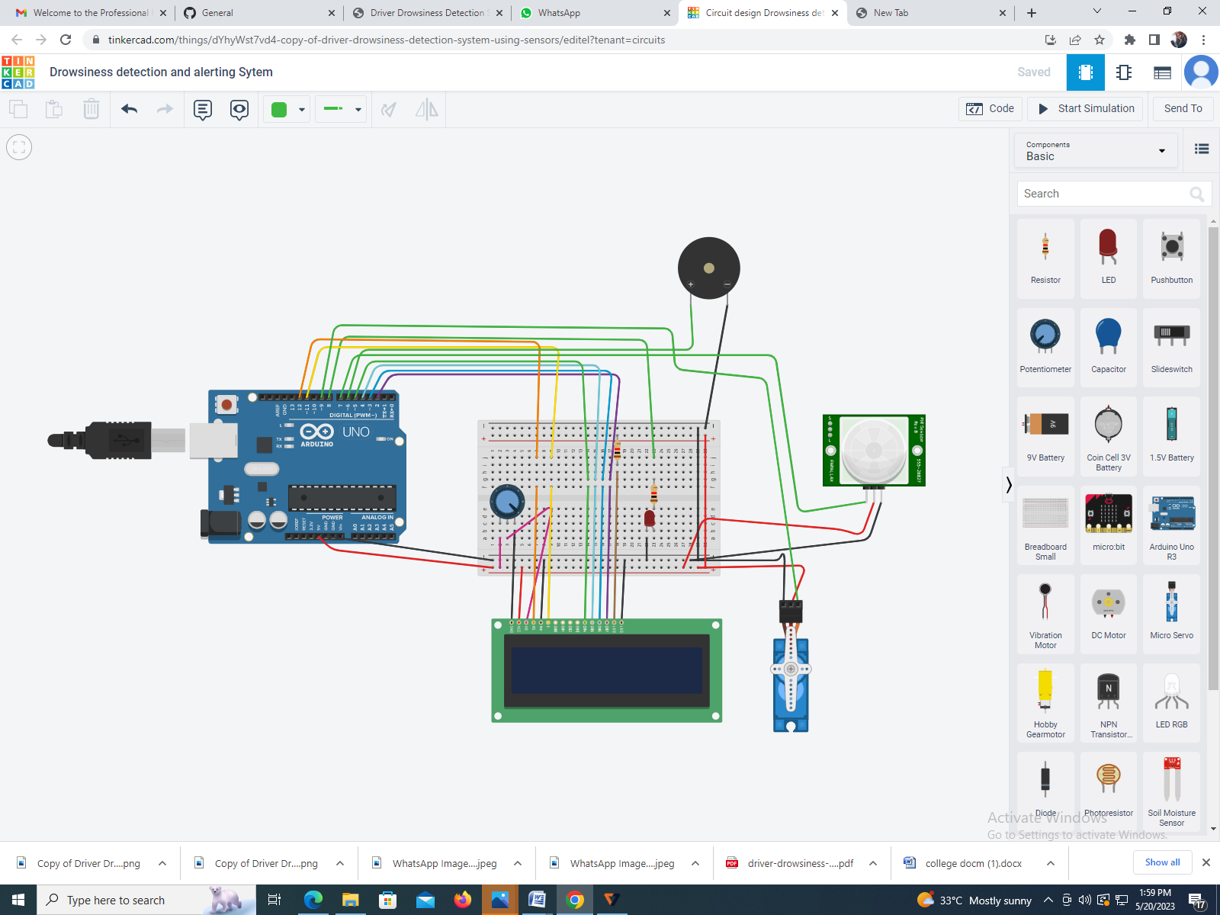

**7 .Advantages & Disadvantages:**

**Advantages :**

* **Accident prevention**:

Drowsiness is a leading cause of accidents, especially in settings such as driving, operating heavy machinery, or working in critical professions. A drowsiness detection system can help identify early signs of fatigue, allowing individuals to take necessary breaks or corrective actions to prevent accidents.

* **Increased safety:**

By alerting individuals when they are becoming drowsy, the system promotes safety in various contexts, such as transportation, manufacturing, healthcare, or any occupation where fatigue-related errors can have severe consequences. It helps ensure that individuals remain alert and responsive during critical tasks.

* **Enhanced productivity**:

Fatigue and drowsiness can significantly impact productivity and performance. A detection and alerting system can help individuals recognize their fatigue levels and take appropriate measures, such as resting or engaging in rejuvenating activities, to maintain their productivity and efficiency.

* **Customizability**:

Drowsiness detection and alerting systems can be personalized based on individual needs and preferences. They can consider various factors, such as individual sleep patterns, behavioral characteristics, and environmental conditions, to deliver tailored alerts and recommendations for managing drowsiness effectively.

* **Early warning signs**:

Drowsiness detection systems can often identify subtle signs of fatigue before an individual even realizes they are becoming drowsy. By providing early warnings, individuals can take preventive measures to avoid drowsiness-related accidents or errors.

* **Real-time monitoring**:

These systems typically provide real-time monitoring, allowing individuals to track their alertness levels continuously. This feedback can help users understand their patterns of fatigue, make informed decisions, and adjust their behavior accordingly.

* **Integration with existing systems**:

Drowsiness detection and alerting systems can be integrated with other safety systems or technologies, such as vehicle systems, wearable devices, or workplace monitoring systems. This integration enables a comprehensive safety approach and facilitates seamless communication and response to potential drowsiness events.

* **Data-driven insights**:

By collecting and analyzing data on drowsiness patterns, these systems can provide valuable insights. This data can help individuals, researchers, and organizations understand the causes and consequences of drowsiness, leading to the development of better fatigue management strategies and interventions.

* **Overall safety culture improvement**:

Implementing a drowsiness detection and alerting system can contribute to fostering a safety-oriented culture within an organization or community. It emphasizes the importance of fatigue management, encourages open discussions about drowsiness-related risks, and promotes proactive measures to mitigate potential hazards.

**Disadvantages:**

* **False Positives**:

These systems may sometimes generate false alerts, mistaking normal driver behavior for drowsiness. For example, sudden head movements or prolonged blinking could trigger an alert even when the driver is fully awake and attentive. False positives can lead to driver annoyance and may reduce the credibility and effectiveness of the system.

* **False Negatives**:

Conversely, the system may fail to detect actual instances of drowsiness, leading to a lack of timely intervention. Factors such as sunglasses, irregular driving patterns, or certain medical conditions could potentially mask the symptoms of drowsiness and prevent accurate detection. False negatives can compromise the safety of the driver and passengers.

* **Invasive Monitoring**:

Some drowsiness detection systems require physical contact with the driver, such as sensors placed on the steering wheel or seat. This level of monitoring may be perceived as intrusive or uncomfortable by some drivers, potentially leading to a reluctance to use the system.

* **Dependence on External Factors**:

The accuracy and reliability of drowsiness detection systems can be influenced by external factors such as lighting conditions, environmental noise, or vehicle vibrations. Variations in these factors may impact the system's performance and increase the likelihood of false positives or false negatives.

* **Maintenance and Calibration**:

Drowsiness detection systems require periodic maintenance and calibration to ensure optimal performance. Over time, sensors may become less accurate or prone to malfunction, necessitating regular checks and maintenance. Failure to maintain the system properly may compromise its effectiveness.

* **Cost and Accessibility**:

Drowsiness detection systems can be expensive to implement, especially in older vehicles that lack built-in capabilities. Retrofitting vehicles with these systems may involve additional costs, limiting their accessibility to a broader population. The cost factor may also influence the willingness of individuals or organizations to adopt these systems.

**8 .Conclusion:**

The drowsiness detection system is capable of detecting drowsiness in quickly. The system which can differentiate normal eye blink and drowsiness can prevent the driver from entering the state of sleepiness while driving. The system works well irrespective of driver wearing spectacles and under low light conditions also. During the monitoring, the system is able to decide if the eyes are closed or opened. When the eyes have been closed for too long a warning signal is issued. The ultimate goal of the system is to check the drowsiness condition of the driver. Based on the eye movements of the driver, the drowsiness is detected and according o eye blink, the alarm will be generated to alert the driver and to reduce the speed of the vehicle along with the indication of parking light. By doing this, many accidents will be reduced and provides safety to the driver and vehicle. A system that is driver safety and car security is presented only in luxurious costly cars. Using eye detection, driver security and safety can be implemented din normal car also.

**9 .Future Scope:**

The future scope may focus on the utilization of outer factors such as vehicle states, sleeping hours, weather conditions, mechanical data, etc. for fatigue measurement. Driver drowsiness poses a major problem to highway safety. 24 hours operations, high annual mileage, exposure to the challenging environmental condition, and demanding work schedules all contribute to the serious safety issue. Monitoring the driver’s state of drowsiness and vigilance and providing feedback on their condition so that they can take appropriate action is one crucial step in a series of preventive measure to necessary to address this problem. Currently there is no adjustment in zoom or direction of the camera during operation. Future work may be automatically zoom in on eyes once they are localized. This would avoid trade-off between having wide field of view in order to locate the eyes, and narrow view in order to detect fatigue.